Media Center Collaboration Request Form
If you would like to bring your classes to the Media Center for research and/or collaborative lessons, please complete all fields below and return the form
(along with any lesson plans, handouts, rubrics, or other information)
as soon as possible via e-mail or print and return to the media specialist.

Teacher: | Winter Semester |  |  |  | Subject Area: | Biology |  | Grade Level: | 6
Dates Requested for Media Center Use  (No more than  3 consecutive days) |  |  | Date 1: | Week Day 1 |  |  | Periods:
 |  |  | Date 2: | Week 1 Day 2 |  |  | Periods:
 |  |  | Date 3: | Week 2 Day 3 & 4 |  |  | Periods:
Lesson/Unit Topic: |  | Ecosystems
Student’s Final Product:  (i.e. research paper, multimedia presentation, poster, oral presentation, report, newsletter/brochure) |  | Documentary video on a unique ecosystem in Georgia.  10 - 15 minutes max.
Subject Standard(s):  Information Literacy Standards: |  | 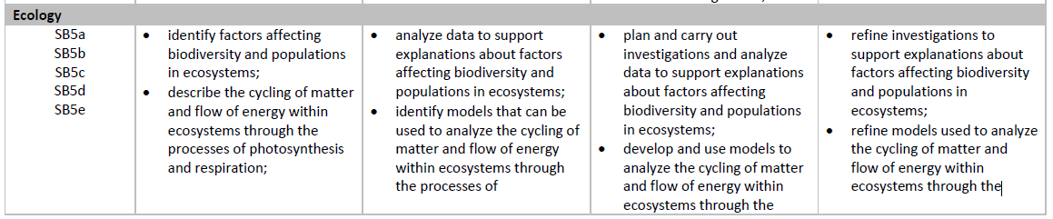  AASL Information Literacy Standards:  Learners develop and satisfy personal curiosity by:  1. Reading widely and deeply in multiple formats and write and create for a variety of purposes.  2. Reflecting and questioning assumptions and possible misconceptions.  3. Engaging in inquiry-based processes for personal growth.
Role of Classroom Teacher: |  | - Introduce the topic of ecosystems, review vocabulary, discuss final project requirements.  - Arrange for guest speakers  - Provide project rubric for student created video
Role of Media Specialist  (during the lesson): |  | - Review MyOn resources in special projects folder. Wk.1 day 1  - Show students how to create their own Collection in Destiny. https://players.brightcove.net/1464976798001/rJf31dMfQ_default/index.html?videoId=5785170483001  - Introduce GALILEO resources related to ecosystems. Wk. 1 day 1  - Assist students with curating resources related to the ecosystem they choose.  - Wk 2 Day 3 – Teach students how to create a storyboard for their video, how to cite sources for their bibliography, and resources for editing their video  - WK 2 Day 4 – Assist students with the creation process for their final product.
What would you like the Media Specialist to do prior to the lesson? |  | Curate a list of resources related to ecosystems in Destiny Collections to share with classes.  Work with the teacher to identify 10 – 15 books and 3 – 5 news articles in MyOn that students can read to become more informed about ecosystems and familiar with the vocabulary.  Identify careers associated with biology studies.  Identify 1-2 videos that introduce the concept of ecosystems.
Comments/
Questions

